Welcome!
Date
Name
Spouse
Address
City
State Zip _________
Email

Please Contact By
❑ Card  Phone  Visit

Telephone Best Time to Call
Home ______________
Work ______________

Guest: First Time Second Time
Are you a church member: yes no
Church
City, State

Circle Appropriate Age/Grade Group(s)
Preschool: Ages: B-1 2-3 4-5
Children: Grades: K 1 2 3 4 5 6
Youth: Grades: 7 8 9 10 11 12
Adults: Ages:18-29 30s 40s 50s 60s+

How did you learn about our church?
Newspaper Friend Yellow Pages Mail
Other

I am a guest of:

New in the Community? Yes No
Names & ages of children at home

Weekly Service & Activity Schedule
December 15, 2013
9:45 a.m. Sunday School
11:00 a.m. Morning Worship

6:00 p.m. Children’s Christmas Program
Fellowship

Week of December 16 – 21

Wednesday, 6:30 p.m. Youth Activities
Wednesday, 6:45 p.m. Adult Prayer & Bible Study
Wednesday, 7:30 p.m. Praise Team Rehearsal
Friday, 5:30 p.m. Adult I S.S. Class Wrapping Party
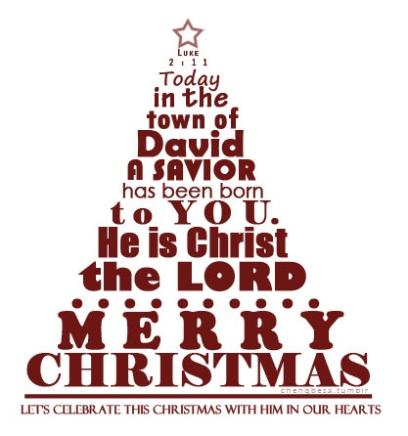

Upcoming Events

December
20 Adult I SS Class Wrapping Party
22 Lord’s Supper
25 Christmas
31 New year’s Eve Watch Night

Knobbs Springs Baptist Church

“Whoever acknowledges me before others,
I will also acknowledge before my Father in heaven.
But whoever disowns me before others,
I will disown before my Father in heaven.
“Do not suppose that I have come
to bring peace to the earth.
I did not come to bring peace, but a sword.
For I have come to turn “‘a man against his father,
a daughter against her mother,
a daughter-in-law against her mother-in-law— a man’s
enemies will be the members of his own household.’
“Anyone who loves their father or mother
more than me is not worthy of me;
anyone who loves their son or daughter
more than me is not worthy of me.
Whoever does not take up their cross and follow me
is not worthy of me. Whoever finds their life will lose it,
And whoever loses their life for my sake will find it.
“Anyone who welcomes you welcomes me, and anyone who welcomes me welcomes the one who sent me.
Whoever welcomes a prophet as a prophet
will receive a prophet’s reward, and whoever
welcomes a righteous person as a righteous person
will receive a righteous person’s reward.
And if anyone gives even a cup of cold water
to one of these little ones who is my disciple, truly I tell you, that person will certainly not lose their reward.”
Matthew 10:32-42

December 15, 2013

Church Information:
KnobbsSpringsBC.com KnobbsSpringsBaptist@gmail.com
1662 CR 305, McDade, Texas 78650 512-273-2743
Brother Dwight Reagan 512-247-6448
Kimberly Tabor, Office Manager 512-698-2804

